**Final Project**

Site which Kitchfix customers can use to enter their zip code to find our delivery fee, delivery days/times, and next available delivery window.

* Approximately 200 different zip codes, split up into four different zones
  + Each zone has a different delivery fee and schedule

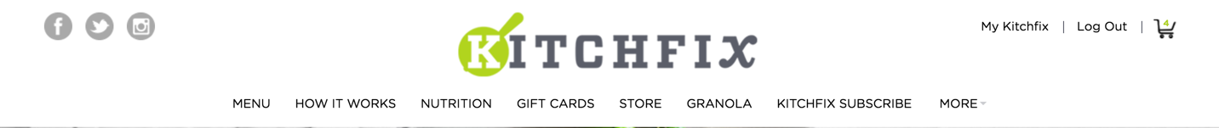

Image of food

HEADER – enter your zip code for delivery price, days, and time windows

FIELD – your delivery zip code

Submit

BEFORE SUBMIT –

* Explanation of home delivery (for home delivery, we use insulated cooler bag, etc.)
  + Text tracking
  + Bag reuse system
* Explanation of hub delivery (come by whenever your hub is open)
  + Link to hub page

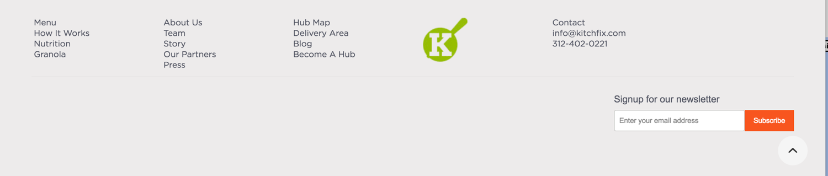

Your next delivery as soon as…

Thursday, 9am-11am



HEADER – enter your zip code for delivery price, days, and time windows

FIELD – your delivery zip code

Submit

ON SUBMIT –

Delivery Fee: $##

Delivery Days:

Monday: ##am-##pm

Tuesday: ##am-##pm

…

…

…

…



Image of food